# Backtest 1: Input Txn is generated from a linear model

Data generation

**Interest rate model: CIR**

Params:

**Bond-cash reserves model: Linear**

*T = 1 (year)*

*dt = 1(minute) = 1/(365*24*60) (year)*

*y0 = 0.5*

*r0 = 5%*

Simulation setup

*r0 = 5%*

*y0 = 0.5*

*kappa = 0.02 (~ r_scalar = 50 in notional finance)*

*r* = 0.05 (~ r_anchor = 1.05)*

V1:

*Linear-model interest rate Linear-model bond, cash reserves*

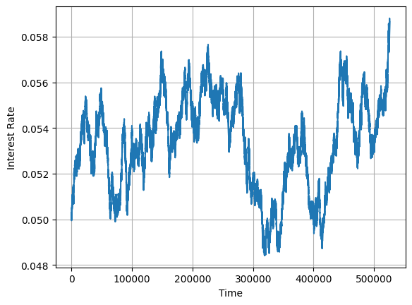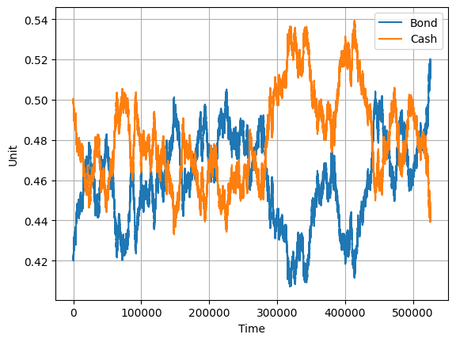

|  |  |  |  |  |  |  |  |  |
| --- | --- | --- | --- | --- | --- | --- | --- | --- |
| **Order size v1** |  |  |  |  |  |  |  |  |
|  | **count** | **mean** | **std** | **min** | **25%** | **50%** | **75%** | **max** |
| **action** |  |  |  |  |  |  |  |  |
| **borrow** | 262873.0 | 0.000127 | 0.000096 | 1.750695e-09 | 0.000051 | 0.000107 | 0.000183 | 0.000746 |
| **lend** | 262726.0 | 0.000127 | 0.000096 | 1.553209e-09 | 0.000051 | 0.000108 | 0.000184 | 0.00075 |

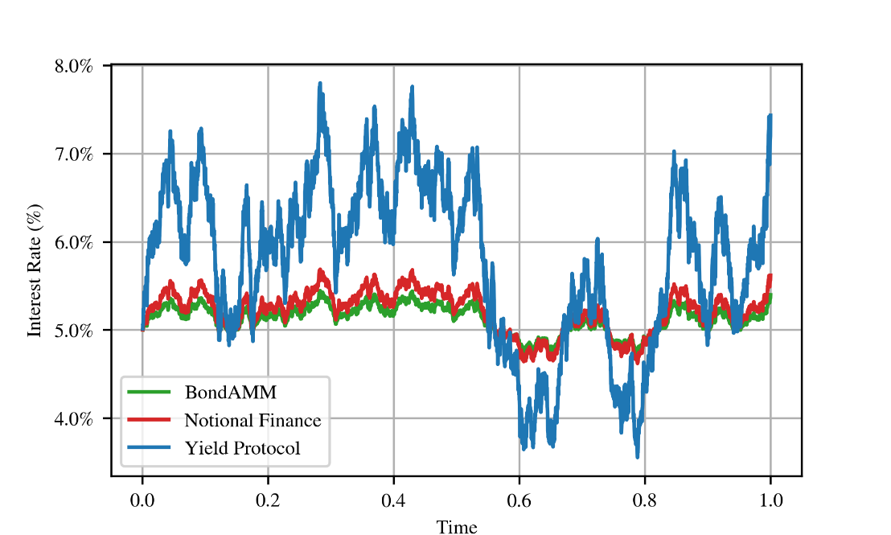

## V2

*Linear-model interest rate Linear-model bond, cash reserves*

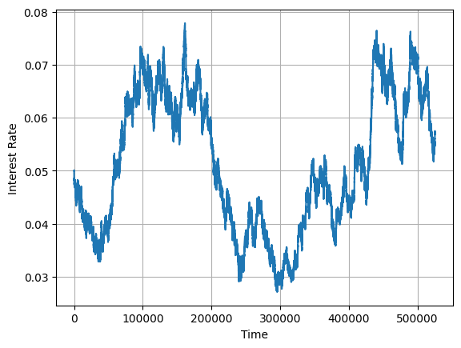 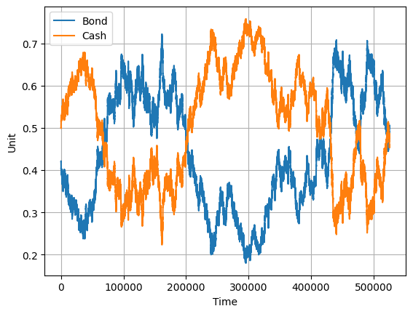

|  |  |  |  |  |  |  |  |  |
| --- | --- | --- | --- | --- | --- | --- | --- | --- |
| **Order size v2** |  |  |  |  |  |  |  |  |
|  | **count** | **mean** | **std** | **min** | **25%** | **50%** | **75%** | **max** |
| **action** |  |  |  |  |  |  |  |  |
| **borrow** | 262769.0 | 0.000515 | 0.000398 | 5.302617e-09 | 0.000203 | 0.00043 | 0.000739 | 0.003346 |
| **lend** | 262830.0 | 0.000515 | 0.000398 | 2.500984e-09 | 0.000203 | 0.00043 | 0.000737 | 0.003412 |

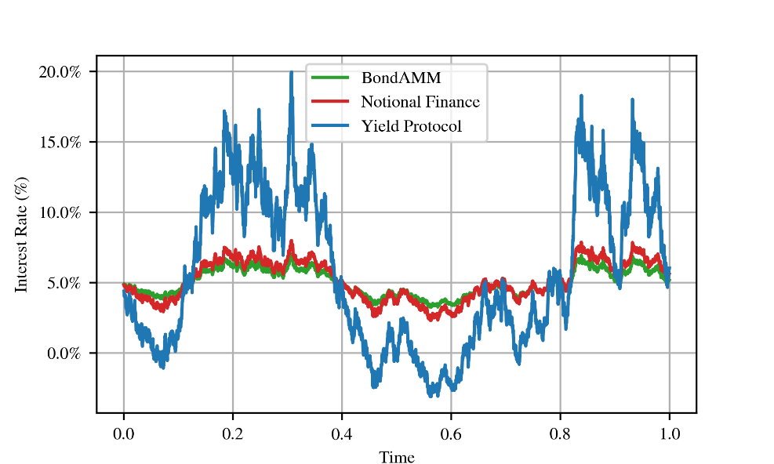

## V3

*Linear-model interest rate Linear-model bond, cash reserves*

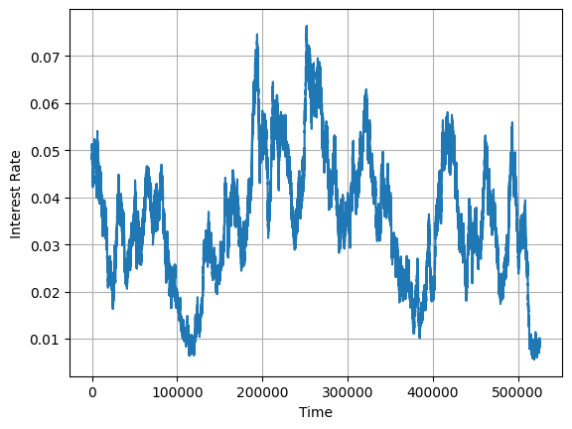 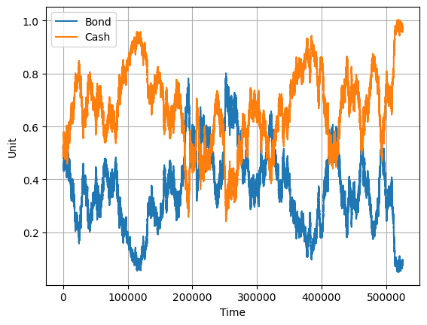

|  |  |  |  |  |  |  |  |  |
| --- | --- | --- | --- | --- | --- | --- | --- | --- |
| **Order size v3** |  |  |  |  |  |  |  |  |
|  | **count** | **mean** | **std** | **min** | **25%** | **50%** | **75%** | **max** |
| **action** |  |  |  |  |  |  |  |  |
| **borrow** | 262436.0 | 0.001057 | 0.000846 | 6.599068e-09 | 0.000402 | 0.000861 | 0.00151 | 0.007144 |
| **lend** | 263163.0 | 0.001056 | 0.000845 | 8.608327e-10 | 0.000401 | 0.000859 | 0.00151 | 0.00713 |

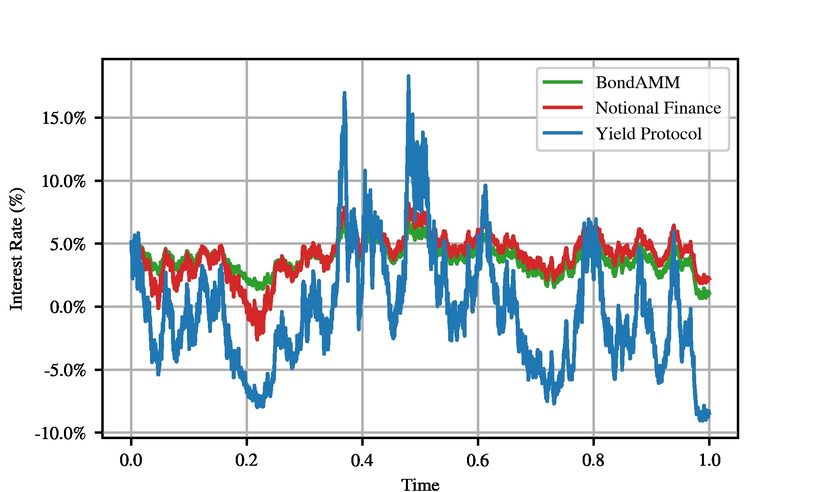

# Backtest 2: There is only an arbitrageur trading to follow a market interest rate, which is simulated from CIR Model